INSPIRED TEAMS

Based on the research behind the concept of Inspired Teams


name
date


© 2020, GEI Partners

Introduction

This report presents your team’s responses to the Inspired Teams Survey. The Inspired Teams Survey assesses team member perceptions of how strongly the team is guided by the habits of the highest performing teams. All teams exhibit patterns of behavior, i.e., habits. In average-performing teams, habits tend to unconsciously emerge. High-performing teams deliberately develop effective habits.

Research shows a link between team performance and the habits in this survey. Still, because each team’s context is unique, the report does not provide solutions or information about which habits are most important for a team. Nor does it provide a prescription for how any habit should manifest itself. The form of each habit should be adapted, by the team, to meet its unique needs.

We recommend that your team discuss the data in this report to decide which habits would be most helpful for improving its process and performance. Priorities for change and the actions that will support change work best when they emerge from team discussions and agreements about the habits that will help the team achieve its goals.

Steven B. Wolff, D.B.A, developed the survey, which is built on the foundation of Team Emotional Intelligence (TEI); TEI has over 20 years of research supporting it.

Contents | Page
Your Team Report | 3
Interpreting and Using the Feedback | 6
Team Performance Overview – Doing Habits | 7
Team Performance Overview – Being Habits | 9
Energy Questions | 11
Purposeful Action Questions | 13
Possibility Questions | 15
Transparency Questions | 17
Team Outcomes | 19
Highest & Lowest Scoring Questions | 20
Responses to Open-ended Questions | 21

Your Team Report

The Inspired Teams Survey measures the strength of your team habits in four essential areas that support team effectiveness, innovation, and the ability to address inevitable tensions and human dynamics: Possibility, Transparency, Energy, and Purposeful Action. In addition, five outcomes of operating as an Inspired Team are measured: Psychological Safety, Team Identity, Constructive Dialogue, Innovation, and Achieving Results.





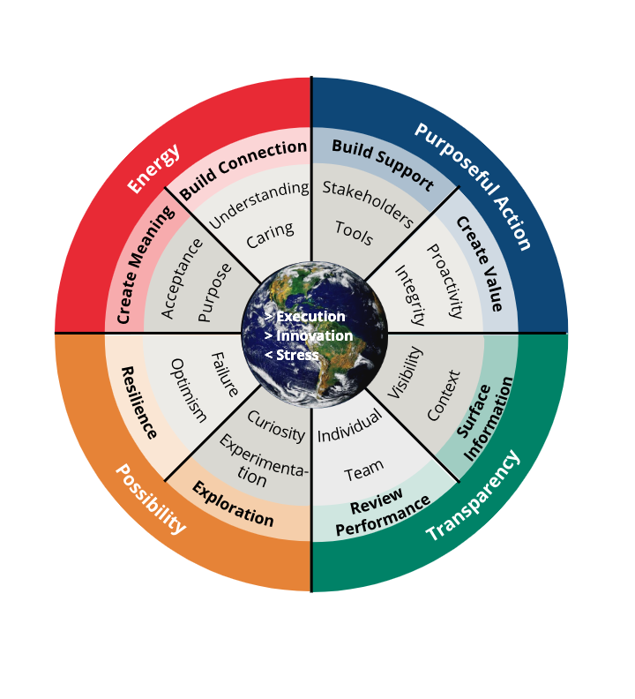

Possibility: This set of habits is mainly a way of thinking that opens the team up to new possibilities. It is a mode where new futures are created, where the “impossible” becomes possible. It lifts the team out of self-limitation and into a mode where it can explore and create without fear, which is a very energetic place to be. People do not live in fear of scarcity, in fear of not measuring up; people are open to possibility and imagine what could be.

The team’s habits facilitate learning and self-organization that produce new and adaptive behaviors. The habitual ways a team interprets its world affects team member energy and their propensity to channel their energy to serve the team. The team’s habits uncover and unlock self-limiting beliefs and self-censorship. The team explores possibilities and, out of those, identifies opportunities. There is no narrative about “what if we fail?” The team is open to the possibility of failure. The team commits to creating a breakthrough and then plans to achieve that commitment; there is a spirit of invincibility.

Transparency: This set of habits is about seeking and surfacing information that is honest and undistorted and making it visible and accessible; it is about having authentic conversations. The focus of Transparency Habits is both internally on the team and externally on understanding the team’s environment, stakeholders, and customers. Each person can take at face value what is being said; what is said is congruent with what is in people’s minds. There is a high degree of integrity and authenticity. When a promise is made people trust it will be kept or renegotiated. People have safety, freedom, and responsibility to be fully self-expressed; there is a bias towards surfacing below the surface emotions and feelings, exploring information accurately without hiding or distorting it, in order to strengthen the team’s ability to deliver results. Everyone has the data needed to make good decisions. Sometimes discussions can be tense, but the team does not shy away.

Each team member is committed to uncovering hidden issues, assumptions, beliefs and commitments that go unquestioned and compete with commitments to the team’s purpose. The team periodically reflects to discover threats to its performance at both the individual and team level and is not afraid to have an honest discussion about the issues from which it learns and adapts accordingly. Members give each other feedback and support so they can bring all their capabilities to the team and grow where desired.

Energy: This set of habits is about bringing your full self to the team and supporting your team members to bring their full selves. The team has a shared meaningful purpose, with each team member energetically and fully committing to the shared purpose. By committing to that purpose, each team member will do whatever is necessary to make that commitment come true. The team acts in such a way that every team member is valued for who they are and supported to bring their full self to the team to achieve the team’s purpose. The emotion and energy when feeling supported by others is extremely powerful. There is a sense that “I am responsible for helping my teammate succeed.” Everyone on the team is responsible for the success of the team as a whole. This is not to say that the team can achieve each member using 100% of their capability and every member being successful, but it is something the team strives for.

Purposeful Action: This set of habits is about acting intentionally to speed progress toward fulfilling the team’s purpose. Waste is eliminated, blocks are removed, resources are attracted, and tools are created to help the team carry through on their commitments and intentions. A team with a shared purpose, striving to make that purpose come true, understands what it needs to make that happen and addresses that need in order to make progress. The team examines actions to ensure that they add value and take care of what the team is committed to. Actions that are not taking care of their commitments are deemed wasteful and are eliminated, although responsibilities to external commitments, such as regulators, are taken seriously. The team engages with stakeholders and resources, is conscious of time wasters and removes these.

Inspired Teams Definition

Inspired Teams is defined as a set of team habits that facilitate execution, innovation, and the team’s ability to work through the natural tensions and human issues that arise as it pursues these outcomes. The result of operating as an Inspired Team is Breakthrough Results. An Inspired Team culture is embodied by a set of sixteen habits, four in each of the above categories. The habits are defined more fully in the following sections that contain your team data.

Team Outcomes

Operating with Inspired Team Norms produces Team Social Capital, relational conditions that support team members’ trust and engagement in the team. Team Social Capital is necessary for achieving high levels of collaboration and performance; however, it cannot be commanded or required of a team. It emerges from team member relationships and interactions, which are shaped by team habits.
The survey includes three elements of social capital: Psychological Safety, Team Identity, and Constructive Dialogue.

Psychological Safety is the degree to which team members feel free to contribute their ideas openly, take risks, and make mistakes. These are important to open communication and sharing of ideas.

Team Identity is the degree to which team members identify with the team. In other words, whether they feel the team is important and more effective working together than working independently.

Constructive Dialogue is the degree to which the team is able to solicit and integrate multiple perspectives without getting into conflict.

The survey also includes two measures of performance: Achieving Results and Innovation.

Achieving Results is the degree to which the team feels it is able to accomplish its goals effectively.

Innovation is the degree to which the team feels it is able to generate new ideas and develop new ways of working that continually improve the team.

Interpreting and Using the Feedback

The ratings in the report represent the average of all responses provided by team members. We recommend looking at the relative ratings across all of the habits and questions, rather than the averages alone. What are the team’s relative strengths and opportunities for improvement? Keep in mind that every team is different and the relevance of specific habits will depend on the team’s work.

The report also includes information about the range of member responses for each habit and each question. Long range bars usually mean that members are having different experiences in the team. This is important for understanding a team’s challenges. For example, long range bars often reveal that some members feel respected and included in the team and some do not, which usually produces uneven participation and levels of engagement.

Avoid the trap of attempting to identify who provided specific responses. Guesses are usually inaccurate. Lower ratings frequently come from brave "truth tellers".

Purpose of the Survey

To: |  | Not to:
 | - Provide data-driven information about a team’s habits that can be used for development and improvement.  - Generate team member dialogue that allows the team to take ownership of its habits and performance.  - Help the team identify action steps that will best help it achieve its goals. |  | - Focus on individual team members.  - Blame team members or stakeholders.

How to Read The Data

Scoring Key | How to read the graphs | Questions to ask when reading the data
1 - Strongly Disagree  2 - Disagree  3 - Neutral  4 - Agree  5 - Strongly Agree | Each graph shows a bar with the mean score (average).  A range bar represents the range of team member ratings from the lowest rating to the highest rating.  The distribution of ratings is not provided because it is not relevant to understanding team functioning. Even one person’s view and behavior can affect team collaboration and performance. | What do the data show to be your  team’s current strengths and  opportunities for improvement?  What patterns or themes emerge from the data?  What stands out to you as behavior that might be hindering your team’s  collaboration and performance?

Team Performance Overview

DOING HABITS
These are habits that guide how members treat each other and how they define their shared goals; they affect the energy of team members. The objective of the Energy habits is to motivate team members by creating an environment of caring, supportive relationships and giving meaning to the work. The objective of the Purposeful Action habits is to build support both internal and external and speed value creation by acting with integrity and managing blocks to progress so the team can get its work done with as little wasted effort as possible.

Energy

Quadrant | Category | Habit | Desired Behavior
Energy | Meaning | Acceptance | - Accept people for who they are  - Create conditions where people can be their full selves in the team.  - Support members to overcome weaknesses  - Support members to use capabilities not typically required by the role.
Energy | Meaning | Purpose | - Create purpose that is shared by all members.  - Create goals that inspire passion.  - Check periodically that all members are aligned and support team goals.
Energy | Connection | Understanding | - Learn about team members’ concerns, needs, pressures, challenges, style, etc.  - Inquire about behavior you don’t understand.  - Offer information that will help team members understand how to best work with you.  - Learn team member competencies and desired growth areas.
Energy | Connection | Caring | - Support team members.  - Validate and appreciate contribution of team members.  - Demonstrate respect  - Accommodate team member needs.

Purposeful Action

Quadrant | Category | Habit | Desired Behavior
Purposeful Action | Support | Stakeholders | - Build connections to people outside the team who can support the team and possibly provide needed resources.  - Support other people and teams outside the team who need the team’s help.
Purposeful Action | Support | Tools | - Make time to discuss tensions in the team.  - Create a language to talk about common issues.  - Create tools to help the team follow through on intentions that result from reflection and learning.
Purposeful Action | Waste | Proactivity | - Proactively anticipate issues that could get in the way of team progress.  - Work to prevent problems before they occur.  - Proactively address challenges to progress.
Purposeful Action | Waste | Integrity | - Promises are kept and the team is notified as soon as it is known there is danger of missing a promise.  - Promises include conditions of satisfaction.  - Everyone takes responsibility for the team’s promises.

BEING HABITS
These are habits about creating shared beliefs and mindsets as well as directing the team’s attention. The mindset of a team and what it focuses attention on have as much effect on energy and progress as what it does. The objective of the Possibility habits is to effectively orient the team to challenge, failure, and uncertainty. The objective of the Transparency habits is to focus attention where it is most helpful to the team’s progress. How the team “sees” things, and where it focuses attention, matters. The team needs to be aware of threats to progress at both the individual and team level.

Possibility

Quadrant | Category | Habit | Desired Mindset
Possibility | Resilience | Optimism | - The team believes it can overcome challenges.  - Challenges are inevitable, the team believes the key is how they deal with them.  - The team maintains a sense of optimism when challenged.
Possibility | Resilience | Failure | - Failures are expected and seen as a learning opportunity.  - Failures should be explored not hidden.  - Failures are an indication of trying hard not deficiency.  - Failure is not to be feared.
Possibility | Exploration | Experimentation | - Under uncertainty, the team believes trying something to get more information is important.  - The team believes trying new ideas is important even though they might not work out.  - The team knows the difference between betting the farm and safe-to-fail experiments.
Possibility | Exploration | Curiosity | - A sense of curiosity propels the team to try new things.  - The team wants to see what will happen when it tries new things.  - Not knowing something arouses curiosity, not fear.

Transparency

Quadrant | Category | Habit | Desired Focus of Attention
Transparency | Performance | Individual | - The team does not let individual performance that hurts the team go unaddressed.  - Team members provide constructive feedback to each other.  - The team recognizes when it does not have the right talent to get the job done.
Transparency | Performance | Team | - The team regularly reflects on what it can learn and how it can be more effective.  - The team methodically monitors its progress.  - The team creates visibility of information needed to assess how it is functioning.
Transparency | Perspective | Visibility | - The team focuses attention on making authentic commitments.  - The team focuses attention on identifying contextual factors that hinder people from keeping their commitments.  - The team focuses attention on transparency when commitments cannot be kept.
Transparency | Perspective | Context | - The team focuses attention on understanding the needs and concerns of leaders.  - The team focuses attention on understanding how to influence those who can provide resources and support.  - The team knows how it contributes to the overall organization.

Energy

The items in this category create engagement in the team's work and align team members. They do this by building Connections and creating Meaning among members. Connections among members are created through norms that create Understanding of Team Members and demonstrated Caring whereby members respect, support, and validate each other. Meaning is created by having a compelling shared Purpose and Acceptance of members as they are and creating roles such that members can bring their full selves to the work and are supported to develop in areas where they would like to grow.

Connection

Understanding

Caring

Meaning

Acceptance

Purpose

Purposeful Action

The items in this category help the team make progress by building Support both internally and externally that helps the team move forward and by proactively eliminating Wasted effort that does not help the team make progress on delivering value for the customer. Support is built externally by building relationships with Stakeholders as well as internally by creating Tools that build emotional capability to handle challenges and address tensions as well as tools to facilitate follow-through on team intentions. Value is created by Proactively anticipating possible obstacles to progress as well as quickly removing blocks when they do arise. The creation of value is also accelerated by acting with Integrity; team members take promises seriously and take responsibility for the promises of the team.

Support

Stakeholders

Tools

Create Value

Proactivity

Integrity

Possibility

The items in this category help teams get through challenges and resolve problems by examining the team’s Resilience when challenged and maintaining a drive for Exploration. The way that the team interprets events has an effect on its ability to innovate. The team needs to remain Optimistic when challenged and have a healthy view of the importance of Failure. Exploration is an important mindset in complex environments where there is a lot of uncertainty and ambiguity. This mindset consists of maintaining a sense of Curiosity and a desire to Experiment, i.e., to try new things and learn from the results.

Resilience

Optimism

Failure

Exploration

Experimentation

Curiosity

Transparency

The items in this category create awareness of threats to Performance and focus attention on gaining Perspective by making information Visible and understanding the Context in which the team operates. The team needs to have a mindset that threats to performance must be made visible at both the Individual and Team levels. It surfaces assumptions, beliefs, and hidden commitments as well as makes its work open and visible. Being aware of the Context requires the team to be aware of its connection to the external environment, especially the customer and how the team adds value.

Performance

Individual

Team

Perspective

Visibility

Context

Team Outcomes

Operating with Inspired Team habits produces Team Social Capital, relational conditions that support team members’ trust in one another and ability to work well together. Team Social Capital is necessary for achieving high levels of collaboration and performance; however, it cannot be commanded or required of a team. It emerges from interactions, which are shaped by team norms. The Social Capital outcomes of Psychological Safety, Team Identity, and Exploring Differences are measured along with ultimate outcomes of Innovation and Achieving Results.

Social Capital Ultimate Outcomes
Psychological Safety | Innovation
Team Identity | Achieving Results
Exploring Differences | Overview

Highest & Lowest Scoring Questions

Highest:

Lowest:

Responses to Open-Ended Questions

1. What is your team doing well and should continue doing?

2. What is your team not doing now that it should start doing?

3. What is your team doing now that it should stop doing?

4. Is there anything else you would like us to know about your team and how it functions?

NOTES:

© 2020, GEI Partners. All rights reserved.

For further information about High-Performing Teams and Inspired Teams, please consult:

W: geipartners.com
T: 1-781-330-0899

